Independent Record Labels of the Internet Era

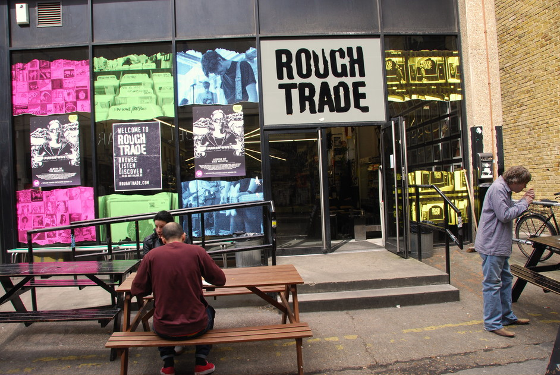

1303193
Kristian Evans
HART (History, Analysis, Repertoire and Theory)
[1.1] Abstract
This report is dedicated to both uncovering and defining the independent record labels during the era of the Internet (i.e. 1998 onwards). A quick look back in history reveals how important independent record labels have been to modern music of the era, helping to alter the perception of contemporary popular music. However over the past two decades, a number of major changes have happened in the marketplace shifting both the power balance and economy.
By utilising primary research (surveys, questionnaires and interviews), it has been concluded that despite large changes to the operations and methods of the music industry, to some degree the essence of what it means to be an indie label has remained constant. Advancements in technology have given musicians and artists more independence and control, however it would prove challenging to realistically compete with what a dedicated label could achieve.

[1.2] Acknowledgements
I would like to thank my lecturer Lloyd George for his contribution to my education. In addition I would like to thank everybody who participated in the research, both record labels and musicians/bands.

Table of Contents
[1.1] Abstract……………………………………………………………………..2
[1.2] Acknowledgements……………………………………………………...3
[2.1] Introduction…………………………………………………………………4
[2.2] Background…………………………………………………………………4
[2.3] Outline………………………………………………………………………..7
[2.4] Methods……………………………………………………………………...7
[3.1] Aims…………………………………………………………………………..8
[4.1] Literature Review…………………………………………………………...9
[5.1] Findings/Results……………………………………………………………11
[6.1] Discussion…………………………………………………………………..13
[7.1] Conclusion…………………………………………………………………15
[8.1] Glossary…………………………………………………………………….17
[9.1] References………………………………………………………………….18
[9.2] Bibliography………………………………………………………………..23
[10.1] Appendix One……………………………………………………………24
[10.2] Appendix Two…………………………………………………………….30
[10.3] Appendix Three…………………………………………………………..36

[2.1] Introduction
Independent record labels have for decades contributed greatly to the music industry; from the rock ’n roll revolution during the 1950s to the development of other genres such as grunge, alternative rock and countless others. [Cosper, A.2012] Some of the most notable companies to date include Rough Trade, Pinnacle, Mute, Factory and 4AD. Rough Trade and Pinnacle alone stood for almost 30% of the music market during their peak; and throughout the 1980s, independent labels would continuously compete with the majors in the top 20 album charts. [King, R., 2012]

[2.2] Background
Tim Berners-Lee’s invention of the World Wide Web in 1989 hit the music industry like a comet. Over the past twenty six years the world has seen a dramatic change in how we consume, distribute, discover and create music; or any form of media for that matter. [World Wide Web Foundation 2015] The introduction of the Internet resulted in a bleak outlook for the music industry. The introduction of digital audio files such as mp3 in 1995 caused hard-copy sales to plummet and the industry to suffer financially. [Fraunhofer-Gesellschaft, 2015]. Illegal file-sharing websites such as Napster and Mp3.com would wreak havoc until their shutdown in 2001.
It was only then that record labels started to integrate into the digital domain. [Cosper, A.2012] [The Napster Controversy, 2015][Kusek, D., 2008.] Record labels (independent or not) seemed unable to keep up with the constant changes that technology brought us. Illegal file-sharing exploded, services such as Piratebay emerged, devastating physical sales. It wasn’t until 2013 that the music had actually seen any form of market growth since 1999. [Neumeister. L., 2015][Admin.,, 2013] [uSwitch., 2015] [Batterbee, A., 2008, p. 82, 83].
With fewer major record labels today, as a result of companies such as EMI being absorbed into Sony and UMG; there has been a reduction in the amount of current market competition. This information also highlights the struggles of the modern music industry as it has attempted to adapt to the changes in technology. [The Nielsen Company & Billboards, 2011] [Pelzie, 2014]
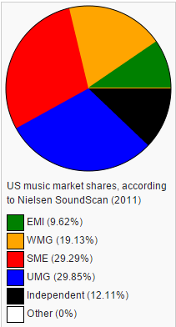
The Nielsen Company & Billboards, 2011
The figure above demonstrates dominance of the four major record labels before EMI’s demise, and to some degree reflects how the independent section relates to them. Although times have changed, the overall picture remains the same as independents are currently a minority.
With regards to the musician’s point of view and the advancement of technology, research indicates that internet based technology and other technological advancements have resulted in more independent control than ever before, from musicians being able to produce high quality albums in their bedroom to even being able to distribute music without the need for a label, alternatively creating their own. [Reevers C., 2011] [Thomson, K., 2015][ Case, C., 2015]
[2.3] Outline
So following the aforementioned changes in the marketplace, where does the independent record label stand?
Interviews, questionnaires and surveys have been used to accumulate information from both the client and business end of the marketplace; this will provide the most accurate and unbiased results.
[2.4] Methods
As previously mentioned, first hand research has been conducted in three fashions. The first being a survey (created via SurveyMonkey), aimed towards the consumer and artists, to determine their overall knowledge about the industry, and also how they have adapted to it. [SurveyMonkey, 2015]
The questionnaire was created as an alternative to the interview. The questions were aimed at the recording labels, and aim to uncover how the businesses are coping.
If the label contacted preferred telephone, a time was agreed to have a recorded interview, where the basis would be the questions used in the questionnaire; interviews were used to get the interviewee to elaborate more in-depth about the inner workings of the indie world.
Record labels were contacted by finding the bands’ homepage on Google, for the interest of aiming it towards the British market place, only British labels were contacted, contact was either conducted via the labels’ online contact form, e-mail or by phoning the company directly.
Social media networking was the primary way of delivering the musicians questionnaire, posting it on social groups dedicated to performing musicians and artists. Due to the nature of the groups and the style of questionnaire, it was not limited to being answered by British based artists, but was aimed at anybody who produced a product for release. (Copies of correspondents, questionnaires and survey results can be found in Appendix 1 – 3).
[3.1] Aims
The intention with this research report, is not to prove that record labels are necessary, but rather if they are necessary, and to some degree decipher the future of record labels.
Musicians can completely bypass recording companies to release their music; some even create personal recording labels for their own release. But can this new found control replace what a recording company does for their musicians?
What do modern music services mean for the industry?
Given all this new technology, how have artists adapted to it? Do musicians today feel confident with the tools they have been given or how does it influence their decision.
As the market developed for 14 years without any real growth, many companies must have felt the pinch. How has the indie section adapted to the recent changes, and has it affected operations?
How do the remaining major labels relate to the indie market of today, is there any resemblance to how things were before?
[4.1] Review of Literature:
Donald S. Passman, 2012. All You Need to Know About the Music Business: Eighth Edition. 8th Edition Edition. Free Press.
Although not specifically about the topic being researched, the book has a couple of chapters that provided useful for the assignment. The book is from 2012 so it is slightly out-dated, but much of the information will still be relevant in today’s market. Passman suggests that record labels function as a quality filter for the consumer; he further suggests that there is no danger to the future of record labels as artists cannot easily achieve the same results as a dedicated label can.
Passman has many relevant views and statements; however the section is very brief with little obvious evidence to support the claims. Much has changed since he wrote this book in 2012, much will happen in the coming years/ decades; though there might not be an immediate threat, the possibility is within reason that artists might also adapt to their new surroundings.
Alex Batterbee, 2008. How to Succeed in the Music Business. 3rd Edition. Omnibus Press.
Written as a guide for musicians and performers to survive in the modern music industry, this book attempts to answer questions and give a rough introduction into how various aspects of the business function in relation to one another. The more relevant section of this book is a chapter dedicated to downloads, podcast, streaming and websites. The introduction to this chapter gives a concise historic and current events view on today’s Industry.
Though the entire book is filled cover to cover in useful tips and information, the book is written in a Q&A form, and as a result large sections are irrelevant to the subject being researched. The sections that are applicable are informative but lack the required depth into the field to be counted as comprehensive. The most recent revision of this book is from 2008, and with drastic changes happening constantly, some of the information might be out of date or inaccurate to modern praxis.

[5.1] Results
The overall research shows that the drive behind running independent labels hasn’t changed much since the before the Internet’s conception; fuelled by the love of DIY, releasing creative and quality records, independent from major label influence. Although the desire to run one hasn’t changed, the entire marketplace has shifted after the introduction of the internet. Amongst other things, independents were no longer restricted by getting distribution deals in order to get music out there. But on the other side of the coin, the internet caused havoc on physical sales maiming a major source of income; albeit, a recent rise in LP sales has occurred over recent years. As a result both bands and record labels have had “to adapt or die”. [Badger, M. (Iron Man Records) (2015). Interviewed by Kristian Evans for Case Study,21:24] [Rushton, K., 2013] [Lewis, L., 2015]
Starting an indie label is relatively easy, with a majority of musicians aware that distribution is possible without a label, more than 50% of the survey’s respondents claim they would consider creating their own label for an upcoming release. DIY in itself is not difficult, but doing it right is a different kettle of fish. Especially as there is no true definition to what is right, what is “right” depends on the surrounding parameters. The benefit of using an established record label is that they can potentially provide understanding, knowledge, experience and resources needed to help the product stand out among the masses; “working with a label that is as old as your band is suicide”. [Badger, M. (2015). Interviewed by Kristian Evans for Case Study, 11:34]

There is some debate as to the existence of the quality filter provided by labels, it is apparent that some labels do specialise in styles, genres or similar and have fan bases that benefit all artists released on that album. With Spotify having 4 million songs that have never been played and countless more struggling due to lack of experience, knowledge or making the wrong decisions. [Rochell, 2013] It is more important now than ever that labels keep up-to date and well informed on current events, in order to provide their artists with optimal results.
Although the introduction of streaming services has driven some money back into the industry’s economy, research reveals that it is only the labels with large amount of copyrights that really benefit, in other words the majors, in contrast iTunes is a highly regarded source due to its design and operation. In recent years 50% of artist’s income has been from live performances; it is therefore important to spread music effectively, market strategically, to reach a wide demographic in order to raise ticket sales. This is an area where an established record label is more likely to see satisfactory results; especially in regards to knowing the market and knowing how to proceed.
D, Passman suggests that the next generation of marketing for bands will rely on direct relationships between the band and its fan base. Research shows that more than 80% of the overall respondents claimed to be comfortable using internet based technology for promotion, 72% of the overall respondents use it actively to connect with the fan base. Having personal relationships and interacting with customers and fans at a personal level can raise the overall success of tours, album releases and so forth, and is actively being used at all stages of the industry, though some of this control can be lost in major label deals. [Passman, D., 2013. 69]
With regards to the major labels, it shows that they have little influence over the independent market, and have somewhat less influence than previously in history; at least what we regard as major labels today. Since the introduction of the internet and later online music services, “new” record labels are emerging under the names such as Apple, Amazon, Youtube and other internet based major corporations; causing competition and a shift in power. In addition to this recent changes and coming changes to the internet and how it operates, such as new laws regarding VAT can make it potentially more difficult to truly be independent.

[6.1] Discussion
The findings provide an up-to-date insight into how the industry currently looks, and a brief outlook on how companies are adapting to their new surroundings. The findings in the report are of significant value as they answer all of the aims and questions posed at the beginning of the report, while additionally giving information into what the current events are. These findings also give an insight into the possible future of the industry.
The report reveals interesting facts such as the diminishing influence of the major record labels (Universal, Sony, Warner Bros) which have previously dominated the market, in favour of an increase in the popularity and trading power of major online corporations that deal in a range of commodities (Amazon, Apple, Ebay) and offer a more convenient and efficient service to those customers buying online.
Companies such as these may become the major labels of tomorrow as they regularly cause havoc in the industry; causing major changes in how the internet functions and how customers make use of the various services available. The days of the Internet providing freedom may be limited with newly established laws and the music industry finally adapting to the monstrous invention that once made the outlook seem grave, though this seems likely to make running an indie label or any indie company more difficult, research has shown how many of these companies are quick to adapt and vigilant in keeping updated about how to deal with coming issues.
The overall findings are important as they ascertain the importance of indie record labels in modern society, showing that they are as important as they ever have been. Despite many artists being comfortable with their new technological surroundings, and being aware of the options available, the majority still see record labels as a necessity.
All of the aims set for this assignment were successfully met, although not all answers are as comprehensive or as useful as initially thought. The research assignment’s main weakness is the lack of responses from labels, the entire research period being dominated by lack of replies or not answering the telephone at arranged time and date. In order for the report to have more credibility and accuracy, more time would be needed to collect responses, where the student would avoid limiting the search to labels within the United Kingdom. The questionnaire in itself requested information that would have been useful to the assignment, but some revisions would be made to it, correcting some phrasing issues and combining questions to make the overall amount less; this might help getting a higher response ratio from participating labels.

[7.1] Conclusion
The assignment was an attempt to ascertain the importance and market position of indie labels after the introduction of the World Wide Web in 1998. It was also to see how companies have adapted to the recent changes and how this has changed operations and the overall definition of “indie”. To answer questions about their market position and also the clients’ view on the industry, both record labels and musicians were contacted with relevant questions to achieve comprehensive answers.
The research shows that over recent years there has been little change to the core elements of being an indie record label, but the internet has caused for drastic changes in what it means to be a record label. Now often not being required for the recording of the actual album, indie labels function as bands PR agents, providing signed artists with resources, knowledge and experience, arming them to their best ability to survive in an industry that no longer thrives on physical sales, but more live performances and strategically supplying music via the various tools available.
Although from the musicians’ or the markets’ point of view there is no immediate danger, society’s adaptation to the internet and other changes in the market place might cause a raised eyebrow.
In many ways this is an impossible question to answer as there is no set definition of indie, it is instead a combination of past actions and mind-set that have evolved over time. To some indie means a seal of approval while to others it is purely a mind-set. What is counted as indie varies much from person to person, with music from all segments of the industry receiving the tag despite its origin.
What it means to be independent also has its grey areas as even self-releasing music one is constricted to major internet based corporations for distribution, and with the new VAT laws being introduced, releasing music for free might be the only remaining way to be truly independent.
s

[8.1] Glossary
Indie – Abbreviation of the word independent, often used as a seal of authenticity or as a way of describing music that contrasts the mainstream.
Independent Record Label – A record label that creates music independent of major label influence; companies that choose to have control over their products rather than the money.
Major Label – Major labels are associated with big corporations, often involving multiple business entities under one Umbrella company such as Universal or Warner Bros.

[9.1] References

admin. 2013. Illegal Download’s Effect on Entertainment Industry | Wall StreetWall Street. [ONLINE] Available at:
<http://www.wall-street.com/2013/04/03/illegal-downloads-effect-on-entertainment-industry/>.
[Accessed 21 February 2015].

Alex Batterbee, 2008. How to Succeed in the Music Business. 3rd Edition. Omnibus Press.

Case, C., 2015. Read: Musicians online without record labels - Journalism & News from Bournemouth UniversityBuzz. [ONLINE] Available at: <http://buzz.bournemouth.ac.uk/musicians-online-labels/>.
[Accessed 23 February 2015].

David Kusek, 2008. The Future of Music: Manifesto for the Digital Music Revolution (Berklee Press). Softcover Edition. Berklee Press.
Donald S. Passman, 2012. All You Need to Know About the Music Business: Eighth Edition. 8th Edition Edition. Free Press.

Fraunhofe-gesellschaft, 2015.The Story of mp3. [ONLINE] Available at: <http://www.mp3-history.com/en/the_story_of_mp3.html#tabpanel-5>.
[Accessed 21 February 2015].
History of the Web – World Wide Web Foundation. [ONLINE] Available at: <http://webfoundation.org/about/vision/history-of-the-web/>.
[Accessed 21 February 2015].

King, R., 2012. How indie labels changed the world | Music | The Guardian. [ONLINE] Available at:
<http://www.theguardian.com/music/2012/mar/22/indie-record-labels-changed-world>.
[Accessed 31 January 2015].

Labels and the Music Industry by Alex Cosper. 2015. History of Record Labels and the Music Industry by Alex Cosper. [ONLINE] Available at: <http://www.playlistresearch.com/recordindustry.htm>.
[Accessed 31 January 2015].

Lewis, L., 2015. Napster 10 Years On - Did File-Sharing Destroy The Music Industry, Or Save It? | NME.COM. [ONLINE] Available at:
<http://www.nme.com/blogs/nme-blogs/napster-10-years-on-did-file-sharing-destroy-the-music-industry-or-save-it>. [Accessed 23 February 2015].
Neuman, L., 2015. MP3.com to Pay $118M in Copyright Case - ABC News. [ONLINE] Available at:
<http://abcnews.go.com/Technology/story?id=119478>.
[Accessed 21 February 2015].

Pelzie, 2014. Now Only Three Major Record Labels | Teach Media. [ONLINE] Available at:
<http://www.teachmedia.org/2011/11/12/now-only-three-major-record-labels/>. [Accessed 18 April 2015].
Reevers C., 2011. 14 Artists Who Launched Their Own Labels [ONLINE] Available at: <http://www.pastemagazine.com/blogs/lists/2011/03/kid-cudi-recently-announced-that.html>.
[Accessed 24 February 2015].

Rochell, 2013. There Are 4 Million Songs on Spotify That Have Never Been Played Once... - Digital Music NewsDigital Music News. [ONLINE] Available at:
<http://www.digitalmusicnews.com/permalink/2013/10/11/songsonspotify>. [Accessed 16 April 2015].

Rushton, K., 2015. Music industry stages a comeback as returns to growth for first time since 1999 - Telegraph. [ONLINE] Available at: <http://www.telegraph.co.uk/finance/newsbysector/mediatechnologyandtelecoms/9894851/Music-industry-stages-a-comeback-as-returns-to-growth-for-first-time-since-1999.html>.
[Accessed 21 February 2015].

Spotify Inc., 2015. I’m an artist, how do I get my music on Spotify? [ONLINE] Available at:
<https://support.spotify.com/uk/learn-more/faq/#!/article/I-m-an-artist-how-do-I-get-my-music-on-Spotify>.
[Accessed 24 February 2015].
Spotify. 2015. Music for everyone - Spotify. [ONLINE] Available at: <https://www.spotify.com/uk/>.
[Accessed 21 February 2015].

SurveyMonkey. 2015. SurveyMonkey - Log in . [ONLINE] Available at:
<https://www.surveymonkey.com/home/>.
[Accessed 10 April 2015].

The Independent . 2015. Who needs record labels? - Features - Music - The Independent . [ONLINE] Available at:
<http://www.independent.co.uk/arts-entertainment/music/features/who-needs-record-labels-1920056.html>.
[Accessed 23 February 2015].

The Napster Controversy, 2015. A Brief History of Napster. [ONLINE] Available at: <http://iml.jou.ufl.edu/projects/spring01/burkhalter/napster%20history.html>.
[Accessed 21 February 2015].

The Nielsen Company & Billboards, 2011. The Nielsen Company & Billboard’s 2011 Music Industry Report | Business Wire. [ONLINE] Available at:
<http://www.businesswire.com/news/home/20120105005547/en/Nielsen-Company-Billboard%E2%80%99s-2011-Music-Industry-Report#.VTKyGCFVhBc>.
[Accessed 18 April 2015].

Thomson, K., 2015. Are Musicians Benefiting from Music Tech? | Artist Revenue Streams. [ONLINE] Available at:
<http://money.futureofmusic.org/are-musicians-benefiting-from-music-tech-sf-musictech-presentation/>.
[Accessed 23 February 2015].

uSwitch., 2015. Broadband History - From the 80s to today, the History of Broadband. [ONLINE] Available at: <http://www.uswitch.com/broadband/guides/broadband_history/>. [Accessed 21 February 2015].

[9.2] Bibliography:
Greg Prato, 2009. Grunge Is Dead: The Oral History of Seattle Rock Music. 0 Edition. ECW Press.
Jordan Johnson, 2014. How to Start a Record Label: The Definitive Guide to Starting and Running a Successful a Record Label (Volume 1). The Definitive Guide to Starting and Running a Successful a Record Label 1 Edition. CreateSpace Independent Publishing Platform
Rob Young, 2006. Rough Trade: Labels Unlimited. 1 Edition. Black Dog Publishing.
The Independent . 2006 Rough Trade: The label that changed music history - Features - Music - The Independent . [ONLINE] Available at: <http://www.independent.co.uk/arts-entertainment/music/features/rough-trade-the-label-that-changed-music-history-415021.html>.
[Accessed 31 January 2015].

[10.1] Appendix One
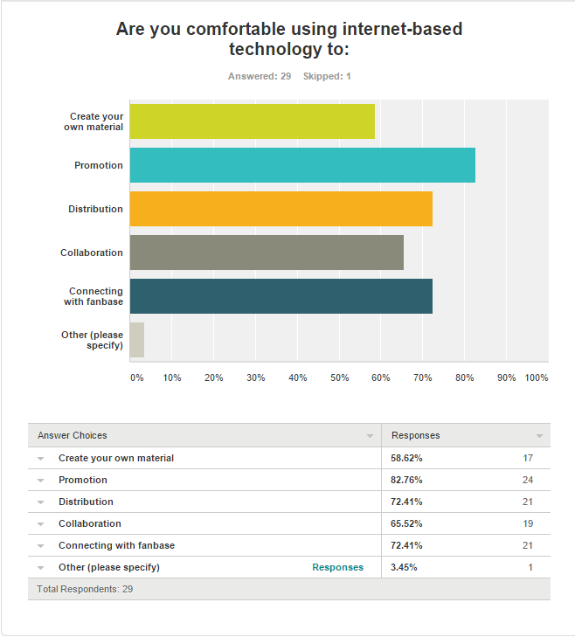
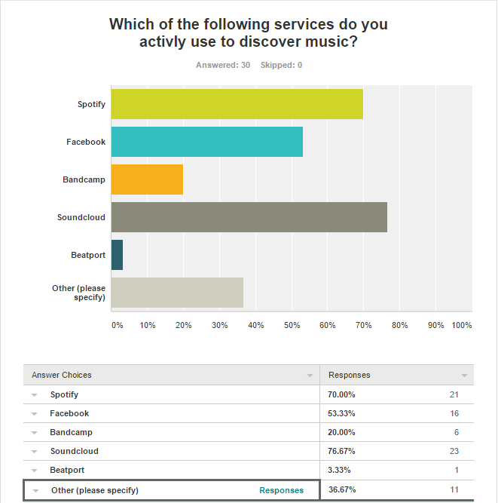
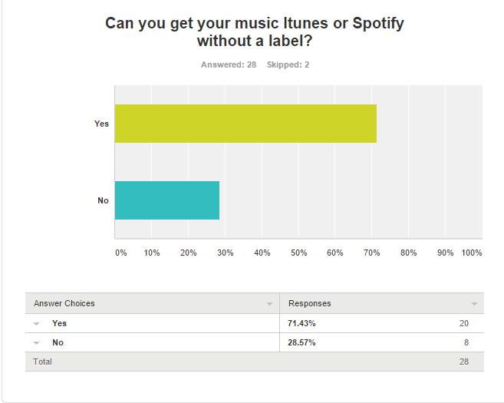
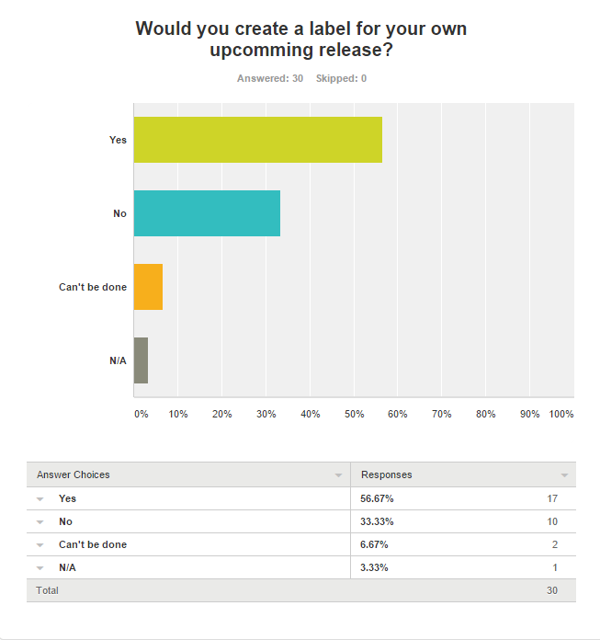
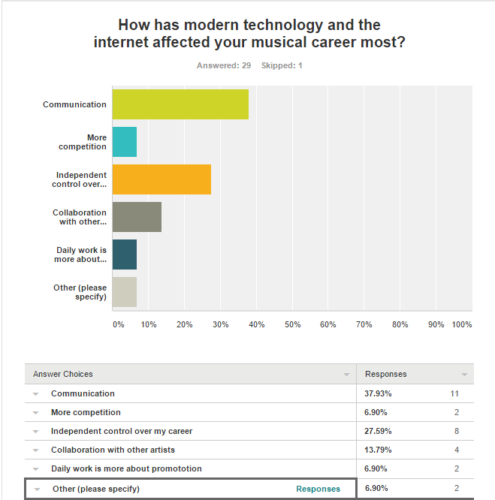

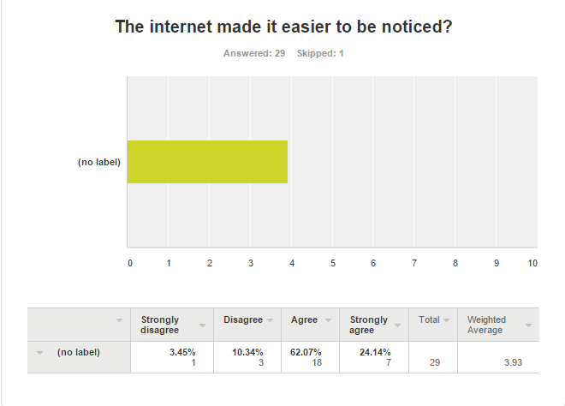
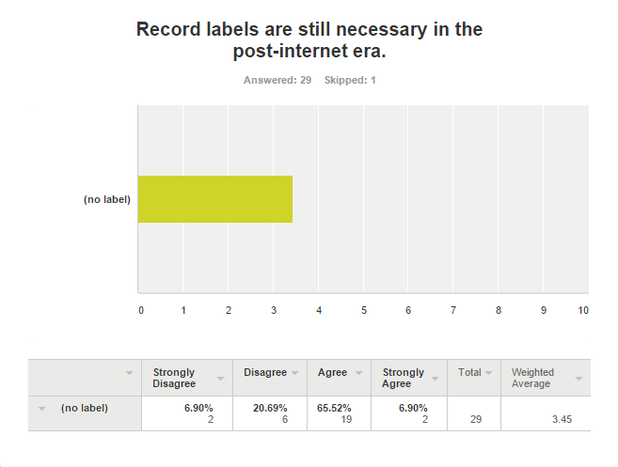
[10.2] Appendix Two
This is a collection of all labels that decided to give written replies to the questionnaire, interviews can be found on the CD handed in.
Graham Stokes – Fat Cat Records
This questionnaire is a part of a case-study conducted by Kristian Evans; an Msc Student at the USW (University of South Wales).
Pre-internet, history provides countless examples of how the independent sector has greatly contributed or altered the music industry. In 1999 when the WWW. Was introduced, the entire world was changed, technologically, socially and economically. In this case study I attempt to uncover what it means to be an indie record label post 1999 and map their importance in the music industry today.
1. What is the motivation behind your label?
To make and release records that people want to buy
2. What makes a Label independent, has this changed after the invention of the internet alternatively would the label exist without it?
I’ve always believed that the term ‘independent’ has no real meaning; independent of what? I would guess that most people define it as being unattached to a major label but more often than not it implies a musical genre that is seen as ‘worthy’.
The internet hasn’t changed things too much as far as being an independent label, people have always made music independently and found a way of selling it. It has however made it easier for artists to self release, this is not the same as being ‘signed’ to an independent label.

3. Over the past two and a half decades the world has seen an extreme increase in technology and communication, to the degree that an artist could theoretically create an album, distribute it and promote it from their bedroom. In light of this, where do you think a record label is needed, what can they offer artists?
The internet clearly gives a pathway directly from artist to listener/viewer, this brings many challenges. Firstly there is a lot of noise out there and being heard above the noise is very difficult, someone ultimately has to promote the music to lift it above the noise. There is also the question of quality control, a subjective issue but experience can be important in making sure that what is put on the net is of the best quality possible.
4. How does a modern record label adapt to an ever growing technological minefield of opportunities? Make great records
How do you get your artists to stand out among the crowd and how has technology changed your operation if at all? Make great records

Services such as Itunes, Vevo and Spotify have contributed to the industries market, making 2013 being the first fiscal year that the music industry had seen growth since 1999. Has the independent sector benefited from this growth and how is it effecting the market? Don’t be fooled by the hype... Streaming services such as Spotify & Vevo currently only benefit labels with a vast number of copyrights; (the majors) where the volume of copyrights is so vast that the payout from these services overall is quite significant. An independent with a small amount of copyrights earns very little from streaming. I can’t speak for the sector but iTunes sales are a great thing for any record label, no manufacture of CDs, no over stocks, no storage costs and no returns!

6. Are there any other reasons for this growth that you are aware of? Don’t be fooled by the hype...
7. How do you view the opportunity these services provide the individuals, are they overall beneficial, or do they pose a threat to the “quality filter” labels have historically provided? Although the “quality filter” is non-existent it’s slightly irrelevant unless you are deluding yourself that the consumer will buy/listen to whatever is released without the filter.
8. What is the future of independent record labels, will they be in the hands of the artist whom wants to promote their own music or the music enthusiast such as the owner(s) of Roughtrade? I resent this question for all the reasons I laid out in answer to your second question. Roughtrade’s owners are indeed music enthusiasts but no more than any other person who works tirelessly to run an independent label. Mike Batt recently had enormous success as an independent with Katie Melua, is he not an enthusiast?
9. How do major labels effect the indie society? The same as in any other industry, they have muscle, vast levels of experience, ‘some’ of the best professionals and of course huge resources. However, they don’t have a monopoly on creativity, that’s something no one can control!

Vanita - RocketGirl
02.03.15
1. What is the motivation behind your label?
The love of music.
2. What makes a Label independent, has this changed after the invention of the internet alternatively would the label exist without it?
I think it's down to funding / distribution and maybe even the style of music
The label has existed prior to the Internet as did many other DIY / bedroom labels on the late 80's / early 90's
3. Over the past two and a half decades the world has seen an extreme increase in technology and communication, to the degree that an artist could theoretically create an album, distribute it and promote it from their bedroom. In light of this, where do you think a record label is needed, what can they offer artists?
A record label sorts the wheat from the chaff.
At one time a label was needed to pay for recording but these days artists can simply record at home with the changing technology, computers, pro-tools etc
A label might have a following or fanbase or release a particular genre of music and they have the money for manufacturing, a great database (invaluable), worldwide distribution in place and experience that a recording artist is unlikely to have
4. How does a modern record label adapt to an ever growing technological minefield of opportunities?
How do you get your artists to stand out amongst the crowd?
(If so why can’t they do this themselves?)
You just have to keep plugging away and believe in what you are doing. Personally I think the bands I work with are incredible and deserve attention and likewise they need to work hard to promote themselves - keep up with social networking sites and tour - I think that's a lot to be dealing with; without the additional role of being the record label too.
5. Services such as Itunes, Vevo and Spotify have contributed to the industries market, making 2013 being the first fiscal year that the music industry had seen growth since 1999. Has the independent sector benefited from this growth and how is it effecting the market?
I think all sectors are benefitting equally. It's how you use the tools to your advantage at the end of the day.
6. Are there any other reasons for this growth that you are aware of?
Maybe the long tail is starting to take affect - there is more music available than ever before and at your finger tips, but I'm not sure...
7. How do you view the opportunity these services provide the individuals, are they overall beneficial, or do they pose a threat to the “quality filter” labels have historically provided?
There will always be quality filter while labels exist.
8. What is the future of independent record labels, will they be in the hands of the artist whom wants to promote their own music or the music enthusiast such as the owner(s) of Roughtrade or Pinnacle?
Well Pinnacle no longer exists!
I think the label and artist work together not at the hands of each other.
9. How do major labels effect the indie society?
Their attitude is throw enough mud and some of it will stick
They will prob continue to hold the majority market share but it doesn't pose a threat as there are so many genres and niche markets that the indies are happy to fill

[10.3] Appendix Three
This is a collation of correspondents with various studios contacted for primary research. All together more than 60 business were contacted. In an effort to save trees and for the usefulness of this section, only correspondents whom replied have been included. This being said, this does not mean that the label actively participated in the research; phone call communication can be found on the CD handed in.
Conversation One: Visible Noise – Kristian Evans
I stand corrected that pinnacle is no longer open, but still funcitons as part of the question.
Did you get the time to answer the remaining questions? :)
Best Regards
Kristian

From: julie@visiblenoise.com
To: evanszz@hotmail.com
Subject: Re: An msc case study
Date: Sun, 5 Apr 2015 14:34:44 +0000
Pinnacle closed down through bankruptcy some time ago killing a lot of labels with it.....!!!
Sent from Julie's Visible Noise+Wiseblood iPhone - apologies for typos!!
On 5 Apr 2015, at 15:27, "Kristian Evans" <evanszz@hotmail.com> wrote:
Sorry for the inconvenience.

From: julie@visiblenoise.com
To: evanszz@hotmail.com
Subject: Re: An msc case study
Date: Sun, 5 Apr 2015 14:00:40 +0000
Can you send in the body of n emil please - I cant open the attachment...
Sent from Julie's Visible Noise+Wiseblood iPhone - apologies for typos!!
On 5 Apr 2015, at 13:23, "Kristian Evans" <evanszz@hotmail.com> wrote:
well here is the questionnaire again attatched to this e-mail, would appreciate your time and help.
Best Regards
Kristian Evans

From: julie@visiblenoise.com
To: evanszz@hotmail.com
Subject: Re: An msc case study
Date: Sun, 5 Apr 2015 01:28:38 +0000
Nope - never received it...
Sent from Julie's Visible Noise+Wiseblood iPhone - apologies for typos!!
On 4 Apr 2015, at 22:50, "Kristian Evans" <evanszz@hotmail.com> wrote:
hello,

Just writing to check up if you ever revived the questionnaire. If you didn't, could I send it again for you to answer?
Best Regards
Kristian Evans

From: evanszz@hotmail.com
To: julie@visiblenoise.com
Subject: RE: An msc case study
Date: Fri, 13 Mar 2015 22:18:07 +0000

From: julie@visiblenoise.com
To: evanszz@hotmail.com
Subject: Re: An msc case study
Date: Thu, 5 Mar 2015 15:34:17 +0000
Sure – send away x

Julie Weir
Visible Noise / Wiseblood Management
25 Powis Terrace London W11 1JJ
Direct line: 0203 220 0381
Mobile: 07958 342494
Email: julie@visiblenoise.com

From: Kristian Evans <evanszz@hotmail.com>
Date: Wednesday, 4 March 2015 15:11
To: Julie Weir <julie@visiblenoise.com>
Subject: An msc case study

Dear Visible Noise
I am an Msc student at the USW (University of South Wales) Currently writing a case study,
in an attempt to map the importance of independent record labels in the post-internet era.
For this to be possible I am contacting as many labels as I can, asking if they would like to answer a short questionnair,
helping me in comming to a conclusive answer.
Hope you are interested in participating, look forward to hearing from you.
Best Regards
Kristian Evans

Conversation Two: Assorted Records – Kristian Evans
Hello Pete,
Following our telephone conversation here are the questions about your label.
thank you very much for your participation it is much appreciated.
Best Regards
Kristian Evans

Conversation Three: Alcopop! Records – Kristian Evans
Date: Mon, 13 Apr 2015 23:49:07 +0100
Subject: Re: University Case Study
From: ilovealcopop@googlemail.com
To: evanszz@hotmail.com
Hey Kristian
Yeah - that should be fine. Pop em over x

On 11 April 2015 at 18:39, Kristian Evans <evanszz@hotmail.com> wrote:
Dear Jack.
I am a student at the USW based in Cardiff, and am currently doing a case study on independent record labels in modern society.
If you have an opportunity to answer a few questions via e-mail or telephone it would be much appreciated. :)
Best Regards
Kristian Evans

Conversation Four: Lab Records – Kristian Evans
Hi Kristian,

Thanks. How is Tues or Weds next week?

Best
On Friday, April 10, 2015, Kristian Evans <evanszz@hotmail.com> wrote:
Hello, Following the phone call we just had.
I am wondering when would be a suitable time to arrange a phone meeting to answer a few questions?
to avoid getting you unprepared in here are the list of questions I will be asking.
Best Regards
Kristian Evans

Conversation Five: House Rox Records – Kristian Evans
From: hello@houseroxrecords.com
To: evanszz@hotmail.com
CC: hello@houseroxrecords.com
Subject: RE: Email From Contact Page
Date: Sat, 11 Apr 2015 19:22:33 +0100
Hi Kristian,
Thanks for your contact.
Please send your questions via email.
Kind Regards,
Louise
Digital Label Enterprise Ltd
Conversation Six: City By Night Records – Kristian Evans
A skype call would be best, are you available anytime this week?
Following is a list of questions I will be asking so you are not surprised by any of them:P
Thank you very much for your participation, it means a lot and is greatly appreciated.
Best Regards
Kristian Evans

Date: Mon, 13 Apr 2015 12:11:17 -0700
Subject: Re: General Enquiries
From: brady@citybynight.co.uk
To: evanszz@hotmail.com
Hi Kristian,
We'd love to answer a few questions for you!,
If you'd like to send them through email, or we could set up a Skype call.
Let us know what you'd like to do, and we'll set something up!
Thanks for the interest!
On Apr 13, 2015 9:10 AM, "Kristian Evans" <evanszz@hotmail.com> wrote:
From: Kristian Evans <evanszz@hotmail.com>
Artist Name: Kristian Evans
Subject: General Enquiries
Track Link:
Message Body:
Dear City by Night.
I am a student at the USW based in Cardiff, and am currently doing a case study on independent record labels in modern society.
If you have an opportunity to answer a few questions via e-mail or telephone it would be much appreciated. :)
Best Regards
Kristian Evans

Conversation Seven: One Note Forever Records – Kristian Evans
Hi Kristian

Sounds great, drop us an email and we'll see what we can do!

Thanks,

Nick
—
Nick Seagrave
Tel: 07525 023560
Digital: www.favouritespoon.com
Records: www.onenoteforever.com
Tweets: @Seagrave
On Sat, Apr 11, 2015 at 7:14 PM, Kristian Evans <evanszz@hotmail.com> wrote:
From: Kristian Evans <evanszz@hotmail.com>
Subject: University Case Study
Message Body:
Dear One Note Forever.
I am a student at the USW based in Cardiff, and am currently doing a case study on independent record labels in modern society.
If you have an opportunity to answer a few questions via e-mail or telephone it would be much appreciated. :)
Best Regards
Kristian Evans
Conversation Eight: Antipop Records – Kristian Evans
Send an email and I'll try and answer.

---------
Alec Joyce
+44 (0)7888 694614
alec@antipoprecords.co.uk
http://antipoprecords.co.uk
https://facebook.com/antipoprecords
http://twitter.com/AntipopUK
On 13 Apr 2015, at 13:50, Kristian Evans <evanszz@hotmail.com> wrote:

From: evanszz@hotmail.com
To: info@antipoprecords.co.uk
Subject: University Case Study
Date: Sat, 11 Apr 2015 18:07:20 +0000
Dear Antipop Records.

I am a student at the USW based in Cardiff, and am currently doing a case study on independent record labels in modern society.

If you have an opportunity to answer a few questions via e-mail or telephone it would be much appreciated. :)

Best Regards
Kristian Evans
Conversation Nine: Small Town America Records – Kristian Evans
nformation Requests (lisa@smalltownamerica.co.uk)
To: evanszz@hotmail.com
Hi
Thanks for your email - due to workload we are not in the position to offer assistance with academic research.
Our blog contains many hundreds of interviews with staff and management that we invite you to look at as this covers our opinions on most music industry subjects
Best of luck with your project.
Best Regards
Team STA

Results from the survey can be found in Appendix One.
Answers to the questionnaires can be found in Appendix Two

